Incident response plan
Hokitika Festival 30 Jan - 02 Feb 2026. Based out of Wests Rugby Club Rooms, Hokitika.
https://nzcanyoningassociation.org/events/hokitika-festival-2026/

Festival response coordinator contact list
The response coordinator is responsible for ensuring that the SAR coordinating authority (NZ Police or RCCNZ) are aware of all the details of the incident and the volunteer resources available at the event.
They will usually be a senior member of NZCA/CanyonSAR.
Work down the list from the top, phoning the numbers until you reach someone - that person becomes Festival response coordinator until the role is transferred to another person.

NZCA Festival organisers
- Alex Waterworth 022 355 3044 (HQ manager)
- Warren Fitzgerald 027 511 1599 (Lead Organiser)
- Dan Clearwater 021 215 7059 (NZCA President)

Canyon SAR team coordinators attending the festival
- Keith Riley 027 291 0440 (West Coast)
- Grant Prattley 027 241 9948 (Canterbury)
- Toine Houtenbos 0210414524 (Tasman)
- Russell Hodgson 021456682 (Upper North Isl)

Canyon SAR team leaders who are not at the event who could assist
- Roy Bailey 027 4386838 (Wanaka)
- Oli Polson 027 5738049 (Tasman)


If no one is contactable, join the Festival Whatsapp group and ask all participants for assistance. https://chat.whatsapp.com/LMCW7R8lurkFOSbbTdVrmO

If still no contact, dial 111 and ask for Police Search and Rescue

Other relevant contact information
Festival participants with advanced medical training:
- Alex Pethrick, (Advanced first aid tutor) 027 766 0028
- Antony Alford (retired anesthesiologist) 0275346468
- Russell Hodgson 021456682

Incident response flowchart

Begin at the red squares and follow the steps
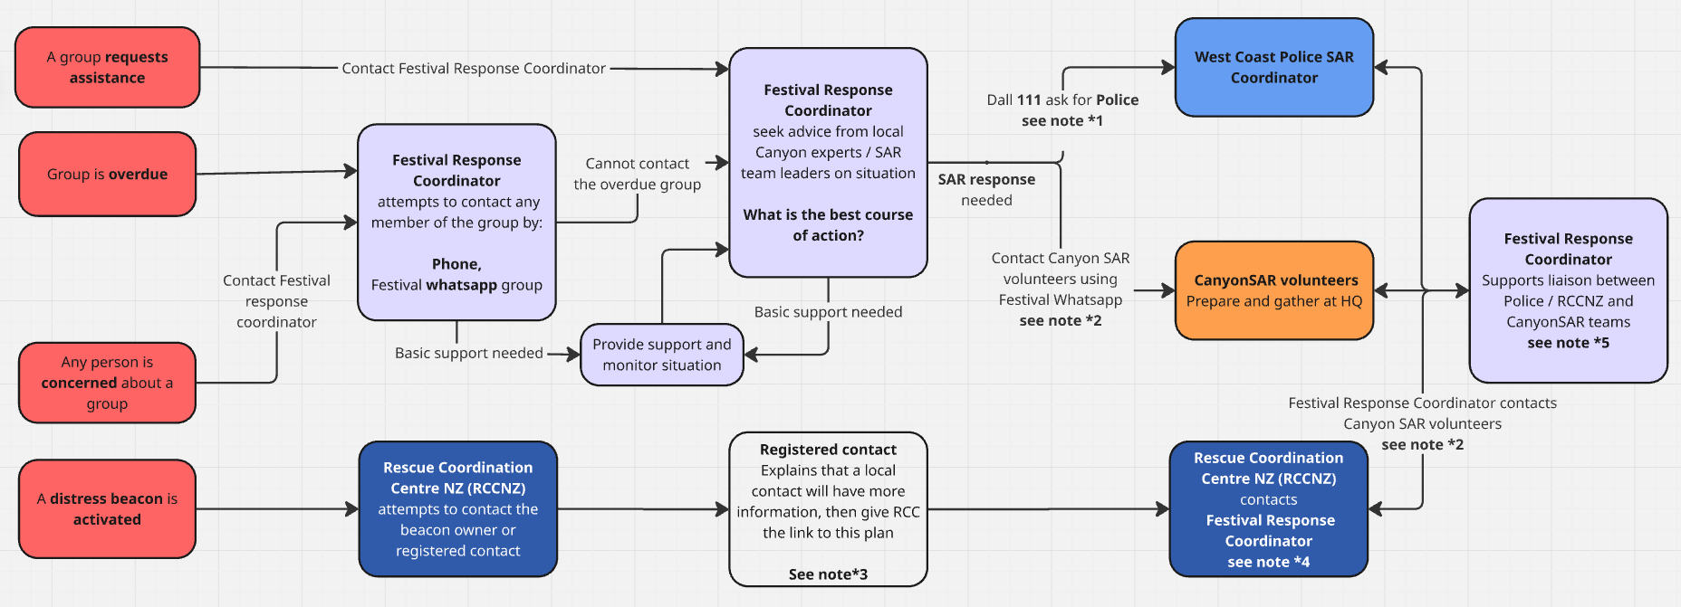

Notes to the flowchart on next page

*1 Contact Police by calling 111
- Say you need a “Search and Rescue response, to a remote location”
- Ask them to inform the duty Police SAR Coordinator for West Coast
- Provide the parties intentions and the location of the festival HQ
- Inform the operator that there are up to 40 canyon specialist LandSAR volunteers around Hokitika.
- Before finishing the call, write down the name and phone number of the duty Police SAR coordinator.

*2 Contacting CanyonSAR volunteers
- Alert CanyonSAR personnel at the festival via the Whatsapp group (join link or QR code) using the templates below.

*SAR response needed: Beacon activation* or *SAR response needed: Overdue party *
The first SAR team leader to read this message, please reply that you are taking the initial role of On Scene Coordinator, then phone the Police officer [name] or RCCNZ officer [name] on [phone number]
All available SAR team leaders meet at HQ to assist OSC.
SAR team members get your gear ready and await further instructions.
No other festival chat is permitted until the SAR response is over.

*3 If a beacon contact person is called by RCCNZ
- Tell them the group is part of an organised club canyoning activity.
  - Explain a local club coordinator is available to assist.
  - Give them the link to this incident plan
  - Ask them to contact the Festival Response Coordinator.

*4 When RCCNZ contacts the Festival Response coordinator
- Whoever receives the call from the Rescue Coordination Centre New Zealand (RCCNZ) should:
  - Explain that you are the Festival Response coordinator.
  - Provide the parties intentions and the location of the festival HQ
  - Inform RCCNZ that there are up to 40 Canyon specialist LandSAR volunteers in the area at the event.
  - Write down the name and ph number of the contact person at RCCNZ.
  - Ask RCCNZ to keep you informed of any developments.

*5 Supporting liaison between Festival Coordinator, Police, RCCNZ, volunteer responders
- Check that a CanyonSAR Team leader has taken the role of On Scene Coordinator and they have made contact with RCCNZ/Police SAR coordinator.
- Liaise with the Police/RCCNZ until a clear handover of responsibility is made from yourself to an On Scene Coordinator.
- Gather any relevant information that may be useful for the Police and/or responders:
  - Canyon Topos
  - Activity (intention) sheets.
  - Weather forecasts / river flow information
  - Participant next of kin details/medical information.

Additional information

Privacy
No one involved in the festival or the SAR operation should post or share Information including opinions/speculation about a SAR operation in progress.
- This has the potential to be hurtful for any family members and confusing to search managers.
- Reporters may be monitoring social media, leading to distractions and unhelpful speculation.
- If you have any information which might be helpful for the operation, give it in person at festival HQ, or call the SAR team leader who has taken responsibility as On Scene Commander.

Dealing with Enquiries

Next of kin enquiries
- During an active incident response, all inquiries by next of kin should be referred to the Police.

Media enquiries
- During an active incident response, all inquiries by media should be referred to the Police.
- Once Police are satisfied the response is complete, any comment from the NZCA should be made by the NZCA president, in consultation with the Police and the event manager.

Helicopter landing zone
For responses requiring a helicopter, the default landing zone H is directly in front of festival HQ.

Hokitika Rugby Grounds / Cass Square -42.719328, 170.968174 WGS84

Preparation

Event manager
- This plan has been adjusted to suit the 2026 Canyoning Festival.
- It must be read in conjunction with the NZCA Safety Management Plan.
- Participants have been made aware that this plan exists and is available online.
- The local CanyonSAR team and Police SAR coordinator are aware of the event and this plan.

Festival Participant
- Tell your next of kin and/or the emergency contacts listed on your personal locator beacon registration the dates you are at the festival.
- Give them the link to this plan and ask them to read it if they have any concerns or in an emergency.

SAR Teams
- Confirm location of KONG 911 and additional SAR equipment - TBC

